FAQ: What is a Workplace Champion?
What is a Workplace Champion?
A workplace champion is a designated employee who helps coordinate, promote, and support participation in the Active Commute Challenge within their organization. They act as the main point of contact between the challenge organizers and their workplace.
What are the main responsibilities of the Workplace Champion?
A Workplace Champion typically:
- Encourages co-workers to sign up and participate
- Shares promotional materials (emails, posters, social media posts, etc.)
- Organizes workplace events or incentives, like group rides or prize draws
- Tracks participation and celebrates achievements
- Communicates updates and reminders about the challenge
Do I need special training to be a Workplace Champion?
No special training is needed. Champions will receive a toolkit with everything they need, including communication templates and promotional material. Champions are encouraged to reach out to TBDHU physical activity team for support.
What are the benefits of being a Champion?
- Recognition within your organization
- A fun leadership opportunity
- Direct contribution to your workplace’s sustainability and wellness goals
- Eligibility for workplace champion prizes
Can there be more than one Champion per workplace?
Absolutely! Having a team of Champions makes it easier to reach more departments, plan events, and maintain energy throughout the Challenge.
How do I become a Workplace Champion?
Simply sign up through the Challenge website and contact us directly. We will get you started with all the tools and support you need and let you know if your workplace currently has an ACC Champion.
Contact: Lenna.Pehkonen@tbdhu.com

Workplace Champion Toolkit
Active Commute Challenge (ACC) 2026 – Workplace Champion Toolkit
Use any of the banners below when you email your workplace team – simply copy and paste it in!

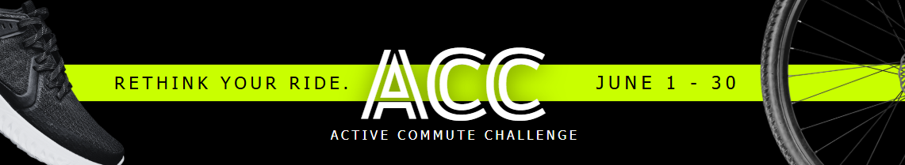

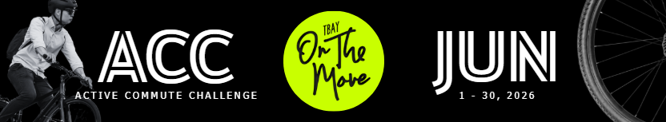
Welcome, ACC Workplace Champion!
The ACC Planning Committee has created this email distribution toolkit with ready-to-send templates that you can copy, paste, and customize. Feel free to edit them or individualize the content to best engage your team and encourage participation in the Active Commute Challenge. Thank you for joining us—we hope to see your workplace on the leaderboard!
www.TBayOnTheMove.ca

Suggested Date: May 19
Email Subject: Join Our Workplace in the Active Commutes Challenge!
Join us for the Active Commutes Challenge from June 1–30! It’s a great way to stay active, reduce your environmental impact, and have some fun.
A few quick things to know:
- Register again this year—even if you’ve participated before.
- Early bird commutes logged starting now are eligible for early bird prizes.
- Every trip where you replace a solo car ride counts—walk, bike, roll, or take transit.
- Be sure to log each trip separately for more chances to win!
Prizes are up for grabs throughout the challenge.
Join our workplace team now and feel free to reach out if you have any questions!

Suggested Date: Week of May 25-29
Email Subject: The Active Commute Challenge (ACC) Is Back for 2026 – Sign Up Today
The Active Commute Challenge is back this June— and it’s time to bring movement back into our daily routines!
Canadian adults spend nearly 10 hours a day sedentary. The good news? Anything is better than nothing.
Your commute is one of the easiest places to reintroduce movement. Walking, cycling, rolling, or combining transit with short walks adds activity to trips you are already making.
Sign up and log an active commute before June 1st to be entered into the early bird prize draws!

Suggested Date: Week of May 25–29
Email Subject: ACC – Plan your move!
Start planning how you will move more this June! Walking, biking, rolling, or getting off the bus one stop early are simple ways to build activity into your routine and reduce sedentary time.
Small changes add up — even one active commute per week makes a difference.
Register before June 1st and log an active commute to be entered into the early bird prize draws!

Suggested Date: Week of June 1–5
Email Subject: ACC – Celebrate Environmental Week!
The 2026 Active Commute Challenge is officially underway — just in time for Environmental Week!
With gas prices still sky-high, there’s never been a better time to rethink your commute. Walking, biking, or rolling even a few days a week can save you money, boost your health, and reduce emissions.
Over 40% of our city’s greenhouse gas emissions come from transportation — every sustainable trip counts. Sign up today to track your commutes, stay active, and compete with workplaces across the city!

Suggested Date: Week of June 1–5
Email Subject: ACC – Prizes to Keep You Moving
Participating in the Active Commute Challenge comes with some great incentives.
Each week, participants will be entered to win 1 of 5 $50 gift cards just for logging their active commutes. At the end of the challenge, top commuters will have the chance to win $100 gift cards.
Workplaces are also competing for special workplace prizes, so help us win!
Check out TbayOnTheMove.ca FAQ’s page for all the prize info!

Suggested Date: Week of June 8–12
Email Subject: Break Up Long Periods of Sitting with the ACC
Driving is one of the most sedentary ways to get around, and can add hours of sitting to your day.
Office workers often sit 70–80% of the day, making it especially important to reintroduce movement where possible.
Adding small bouts of movement can increase energy and lower long-term health risks. Sign up for the Active Commute Challenge and try one active commute this week.

Suggested Date: Week of June 8–12
Email Subject: Move More, Sit Less — Join the ACC
National data shows only about one-third of adults reach 7,500 steps per day. That means most of us have room to move a little more.
Replacing just one short car trip can help close that gap. A few extra minutes of walking or cycling during your commute adds up over time.
Join the Active Commute Challenge and start building movement into your day.

Suggested Date: Week of June 15–19
Email Subject: ACC – Short Trips, Big Impact
Many adults live within a short distance of work, yet still drive.
With many rush-hour trips under 5 km, even one active commute a week—walking, biking, or combining transit with short walks—can reduce sedentary time, boost health, and support well-being.
Join the Active Commute Challenge today and try an active commute today!

Suggested Date: Week of June 15–19
Email Subject: ACC – Check Out The Leaders
The 2026 Active Commute Challenge is in full swing—and the leaderboard is heating up! Check out which workplaces are in the lead and see how our team stacks up.
It’s not too late to make a difference. Keep logging your active commutes—walking, biking, rolling, or combining transit with short walks—through the end of the month for a chance to win weekly prizes and help us climb the leaderboard!

Suggested Date: Week of June 22–26
Email Subject: ACC – Physical Health Benefits Add Up
Did you know you can be physically active and still sedentary?
Even if you’re active for 30 minutes a day, sitting too much the rest of the time can still put your health at risk. Breaking up long periods of sitting is important for your health.
Small bouts of movement—like walking to a meeting, heading out for lunch, or actively commuting—help interrupt sitting time and add more movement to your day. Remember: any movement is better than none.
Sign up for the Active Commute Challenge and start moving more throughout your day.

Suggested Date: Week of June 22-26
Email Subject: ACC – Movement Supports Mental Health
Sedentary behaviour affects more than physical health. Long periods of sitting are associated with increased stress, lower energy, and reduced concentration.
Adding movement to your commute can improve mood and help you begin and end your workday feeling energized, refreshed, and focused.
Register for the Active Commute Challenge and try an active commute today!

Suggested Date: Week of June 30
Email Subject: ACC Final Call – Keep Moving Forward
As the Active Commute Challenge wraps up, remember that the goal was progress — not perfection.
Whether you added one active commute or many, you’ve taken steps toward reducing sedentary time and improving long-term health.
If you haven’t signed up yet, there’s still time to participate and log your commutes. Keep building movement into your daily routine — because anything is better than nothing.

