**FAQ: What is a Workplace Champion?**

**What is a Workplace Champion?**

A **Workplace Champion** is a designated employee who helps coordinate, promote, and support participation in the Active Commute Challenge within their organization. They act as the main point of contact between the challenge organizers and their workplace.

**What are the main responsibilities of a Workplace Champion?**

A Workplace Champion typically:

* Encourages co-workers to sign up and participate
* Shares promotional materials (emails, posters, social media posts, etc.)
* Organizes workplace events or incentives, like group rides or prize draws
* Tracks participation and celebrates achievements
* Communicates updates and reminders about the challenge

**Do I need special training to be a Workplace Champion?**

No special training is needed. Champions will receive a toolkit with everything they need, including communication templates and promotional material.  Champions are encouraged to reach out to TBDHU physical activity team for support.

**What are the benefits of being a Champion?**

* Recognition within your organization
* A fun leadership opportunity
* Direct contribution to your workplace’s sustainability and wellness goals
* Eligibility for workplace champion prizes

**Can there be more than one Champion per workplace?**

Absolutely! Having a team of Champions makes it easier to reach more departments, plan events, and maintain energy throughout the challenge.

**How do I become a Workplace Champion?**

Simply **sign up through the challenge website** and contact us directly. We will get you started with all the tools and support you need and let you know if your workplace currently has an ACC champion.

**Contact:** [**Leena.Pehkonen@tbdhu.com**](mailto:Leena.Pehkonen@tbdhu.com)

**Workplace Champion Toolkit**

Use any of the banners below when you email your workplace team – simply copy and paste it in!



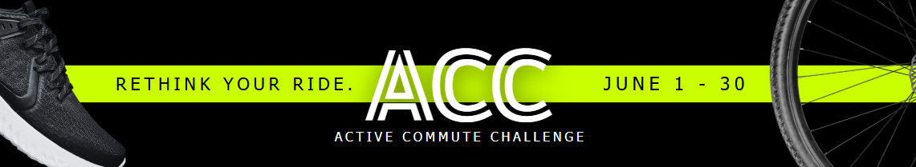

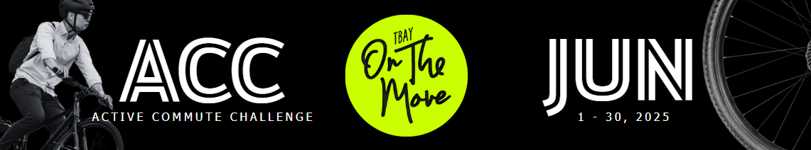

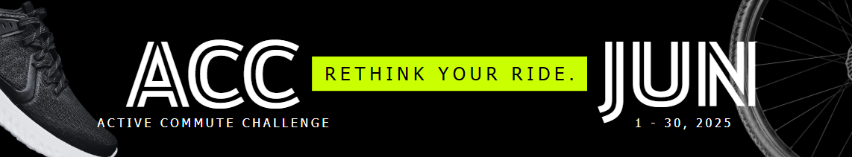

**Welcome, ACC Workplace Champion!**  
The ACC planning committee has created this email distribution toolkit with ready-to-send email templates that you can copy and paste. Feel free to use them internally to help encourage and motivate your workplace to participate in the Active Commute Challenge. Thank you for joining us—we hope to see your workplace on the leaderboard!  
[www.TBayOnTheMove.ca](http://www.TBayOnTheMove.ca)

**Suggested Date: Week of May 20–23**  
**Email Subject: Active Commute Challenge (ACC) – Start planning your commute!**

TBayOnTheMove’s Active Commute Challenge (ACC) is coming up this June! We’re encouraging everyone to choose sustainable commuting options such as walking, biking, public transit, or carpooling throughout the month.

Planning a sustainable commute involves several key steps to reduce your environmental impact while keeping your commute practical and efficient. Check out TBayOnTheMove’s [How to Plan Your Sustainable Commute.](https://tbayonthemove.ca/wp-content/uploads/2025/04/PlanSustainableCommutes11x8.5in1-compressed.pdf)

**Suggested Date: Week of May 26–30**  
**Email Subject: ACC Registration is Now Open – Early Bird Prizes Up for Grabs!**

It’s time to register for the Active Commute Challenge! Anyone who registers before June 1 and logs an active commute during the first week of the challenge will be entered into a draw to win one of five early bird prizes, including a bike tune-up or a $100 gift card to a local bike shop. Check out TBayOnTheMove’s [FAQs page](https://tbayonthemove.ca/faqs/) for more info on prizes.

[Register now](https://tbayonthemove.ca/) and start planning your sustainable commutes!

**Suggested Date: Week of June 2–6**  
**Email Subject: Canadian Environmental Week – Join the ACC!**

Celebrate Canadian Environmental week by [joining the Active Commute Challenge](https://tbayonthemove.ca)! By walking, biking, taking transit, or carpooling, you’ll help reduce emissions and contribute to a healthier, more sustainable Thunder Bay.

Over 40% of our city’s greenhouse gas emissions come from transportation. Every sustainable commute makes a difference. Sign up today to track your commutes, stay active, and compete with workplaces across the city!

**Suggested Date: Week of June 2–6**  
**Email Subject: Canadian Environmental Week – What Are GHGs?**

About 90% of people in Thunder Bay produce greenhouse gases (GHGs) just getting to and from work.

This happens because driving burns fuel, releasing greenhouse gases such as carbon dioxide, methane, and nitrous oxide. These invisible and odorless gases accumulate in the atmosphere and trap heat—ultimately contributing to climate change.

The good news? **Small changes help**. Walking, biking, or even carpooling just a few times a week cuts down your emissions—and it adds up fast. [Join the Active Commute Challenge](https://tbayonthemove.ca/) today!

**Suggested Date: Week of June 9–13**  
**Email Subject: The Active Commute Challenge Is in Full Swing!**

Curious how our workplace is doing? Check out the leaderboard to see our progress! If you haven’t signed up yet, there’s still time to [join](https://tbayonthemove.ca/)—start logging your active commutes and help boost our total kilometers.

There are some great prizes up for grabs this year! The more often you replace your car with a sustainable commute, the better your chances of winning. Each week, five lucky participants will win a $50 e-gift card.

Visit the [FAQ page](https://tbayonthemove.ca/faqs/) for prize details and start logging your commutes today!

**Suggested Date: Week of June 9–13**  
**Email Subject: ACC – Every Little Bit Counts**

Did you know that nearly half of Thunder Bay residents live within a 15-minute walk or bike ride from work? And almost 50% of rush hour trips are under 5 km—yet many people still drive gas-powered cars for these short distances.

This week, why not replace one of those short trips with a sustainable commute? Whether it’s walking, biking, or taking transit, it’s an easy way to reduce emissions and support a healthier community.

Let’s make every commute count!

[TBayOntheMove.ca](https://tbayonthemove.ca/)

**Suggested Date: Week of June 16–20**  
**Email Subject: ACC and Physical Health**

Regular physical activity is essential for overall health and well-being. Active commuting is a great way to incorporate movement into your daily routine. It supports cardiovascular health and lowers the risk of chronic conditions like high blood pressure, type 2 diabetes, and heart disease.

The Canadian 24-Hour Movement Guidelines recommend at least 150 minutes of moderate-intensity physical activity per week for adults. Active commuting can help you meet this goal without needing extra time for exercise.

Whether you walk, bike, or combine transit with walking, choosing active transportation is a practical, sustainable way to improve your health.

[TBayOnTheMove.ca](http://www.TBayOnTheMove.ca)

**Suggested Date: Week of June 16–20**  
**Email Subject: ACC and Mental Health**

Active commuting not only supports your physical health—it also benefits your mental well-being. Research shows that people who actively commute report better mental health than those who don’t. It can reduce symptoms of anxiety and depression while improving mood and overall well-being.

It may also boost productivity and job satisfaction, creating a positive shift in workplace culture. All the more reason to join our team!

[Log in or register now](https://tbayonthemove.ca/) to see our current team members and get involved.

**Suggested Date: Week of June 23–27**  
**Email Subject: ACC – There’s Still Time to Join the Challenge!**

We’re in the final week of the Active Commute Challenge—thank you to everyone who has already logged their active commutes!

If you haven’t [signed up](https://tbayonthemove.ca/) yet, there’s still time to join. Log your commutes this week to qualify for a chance to win exciting prizes. Every commute counts, and the more you log, the better your chances of winning.

Let’s finish strong! We appreciate your participation and can’t wait to see how many kilometers we add to the board in this final week.

**Suggested Date: June 30**  
**Email Subject: ACC – Last Day! Stay Tuned for Prize Draws**

Today is the final day of the Active Commute Challenge, and we want to extend a huge thank you to everyone who participated. Whether you walked, biked, bussed, or carpooled, your commitment to sustainable commuting has made a real difference.

Don’t forget to [log all of your commutes](https://tbayonthemove.ca/)—you have until midnight tonight!  
Prize draws will take place this week, so keep an eye on your inbox!